**CSV file having data:**

OrderDate,Region,Rep,Item,Units,Unit Price

4-Jul-2014,East,Richard,Pen Set,62,4.99

12-Jul-2014,East,Nick,Binder,29,1.99

21-Jul-2014,Central,Morgan,Pen Set,55,12.49

29-Jul-2014,East,Susan,Binder,81,19.99

7-Aug-2014,Central,Matthew,Pen Set,42,23.95

15-Aug-2014,East,Richard,Pencil,35,4.99

24-Aug-2014,West,James,Desk,3,275

1-Sep-2014,Central,Smith,Desk,2,125

10-Sep-2014,Central,Bill,Pencil,7,1.29

18-Sep-2014,East,Richard,Pen Set,16,15.99

27-Sep-2014,West,James,Pen,76,1.99

5-Oct-2014,Central,Morgan,Binder,28,8.99

14-Oct-2014,West,Thomas,Binder,57,19.99

22-Oct-2014,East,Richard,Pen,64,8.99

31-Oct-2014,Central,Rachel,Pencil,14,1.29

8-Nov-2014,East,Susan,Pen,15,19.99

17-Nov-2014,Central,Alex,Binder,11,4.99

25-Nov-2014,Central,Matthew,Pen Set,96,4.99

4-Dec-2014,Central,Alex,Binder,94,19.99

12-Dec-2014,Central,Smith,Pencil,67,1.29

21-Dec-2014,Central,Rachel,Binder,28,4.99

29-Dec-2014,East,Susan,Pen Set,74,15.99

6-Jan-2015,East,Richard,Pencil,95,1.99

15-Jan-2015,Central,Bill,Binder,46,8.99

23-Jan-2015,Central,Matthew,Binder,50,19.99

1-Feb-2015,Central,Smith,Binder,87,15

9-Feb-2015,Central,Alex,Pencil,36,4.99

18-Feb-2015,East,Richard,Binder,4,4.99

26-Feb-2015,Central,Bill,Pen,27,19.99

7-Mar-2015,West,James,Binder,7,19.99

15-Mar-2015,West,James,Pencil,56,2.99

24-Mar-2015,Central,Alex,Pen Set,50,4.99

1-Apr-2015,East,Richard,Binder,60,4.99

10-Apr-2015,Central,Rachel,Pencil,66,1.99

18-Apr-2015,Central,Rachel,Pencil,75,1.99

27-Apr-2015,East,Nick,Pen,96,4.99

5-May-2015,Central,Alex,Pencil,90,4.99

14-May-2015,Central,Bill,Pencil,53,1.29

22-May-2015,West,Thomas,Pencil,32,1.99

31-May-2015,Central,Bill,Binder,80,8.99

8-Jun-2015,East,Richard,Binder,60,8.99

17-Jun-2015,Central,Matthew,Desk,5,125

25-Jun-2015,Central,Morgan,Pencil,90,4.99

Tableau Worksheets:

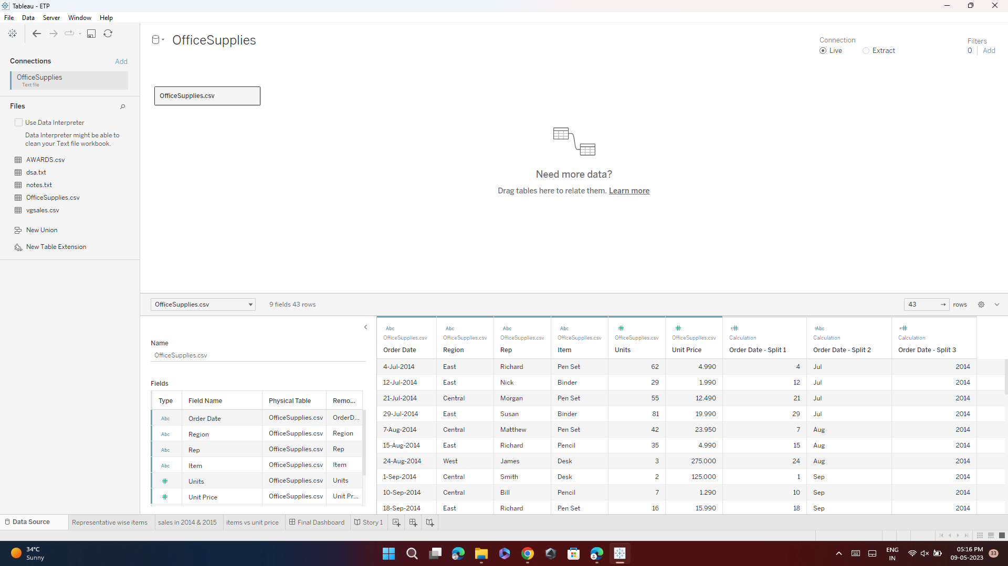

Line Chart : Representatives wise units more than one items

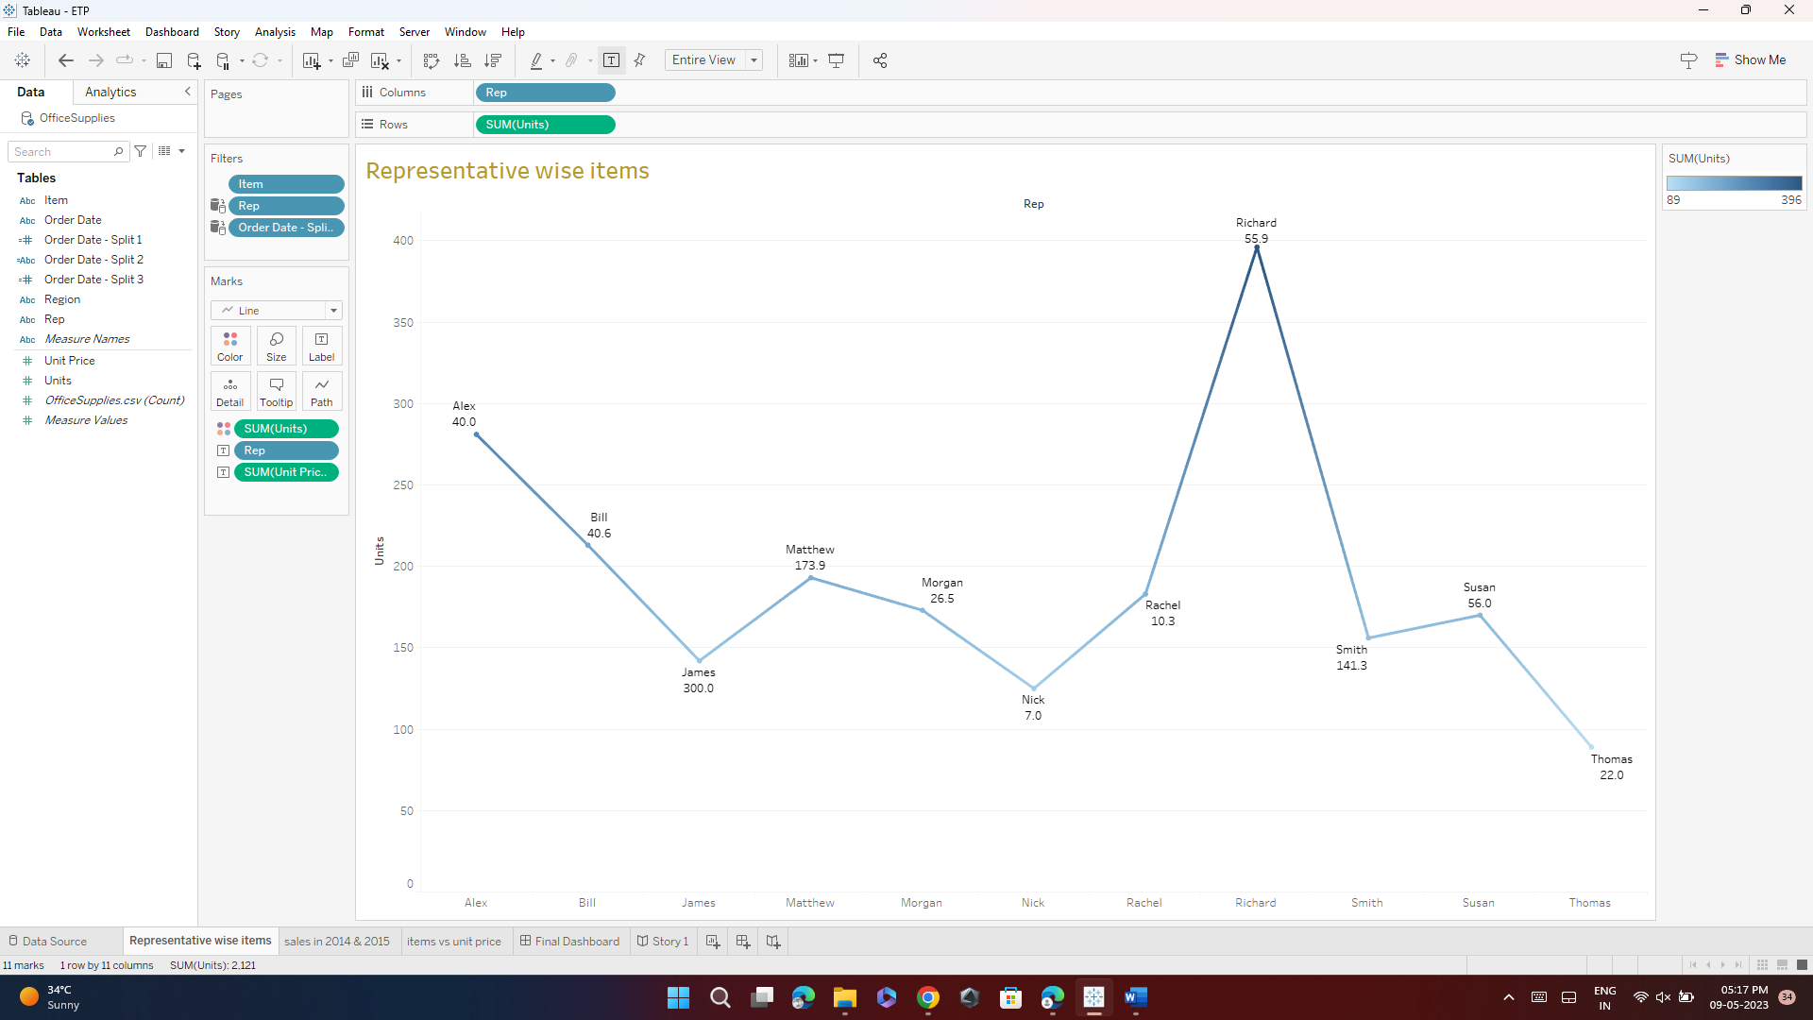

Bar chart : sales done by representatives in 2014 & 2015

Waterfall chart : Representing Item vs Unit Price

Final Dashboard

Story on Representative's Unit Items

